

License Update Lab Writeup

Sophia Zhang | Period 5 Cybersecurity | 2022-2023



**Purpose**

The purpose of this lab was to perform a license update on a Palo-Alto PA-220 firewall.

**Background**

Firewalls are security devices that that monitors traffic to and from our networks, and blocks traffic based off security rules. Firewalls allow us to have access to the internet, but also prevents others from the internet from accessing resources on our internal network. Firewalls are present in SOHO networks.

It is important to keep firewalls up to date to gain access to new features and improved software performance. Also, many times, updates come with software bug and performance fixes, which improves the useability of the firewall. The point of firewalls is to prevent certain types of traffic from entering the network, and updated firewalls offer advanced functionality. For example, we would gain better web usage control, malware detection, automated intervention, VPN support, and application awareness. As always, having an updated firewall will be better than having a security breach.

**Lab Procedure**

1. Go to device – license and click retrieve license keys

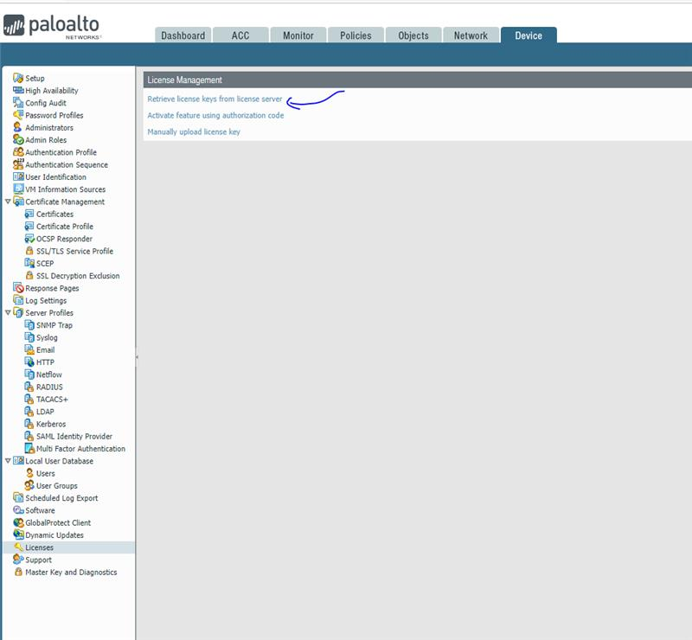

1. Go to device 🡪 software and click “Check Now”

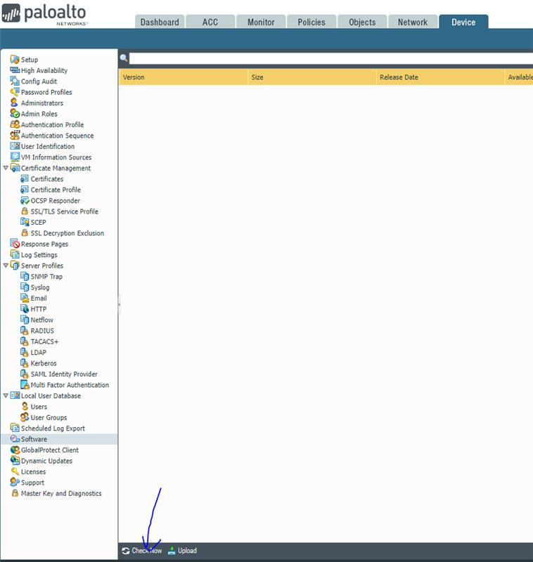

1. Update to the latest version (ex 8.0.1 to 8.0.9 to 8.1.0 to 8.1.9 etc.)

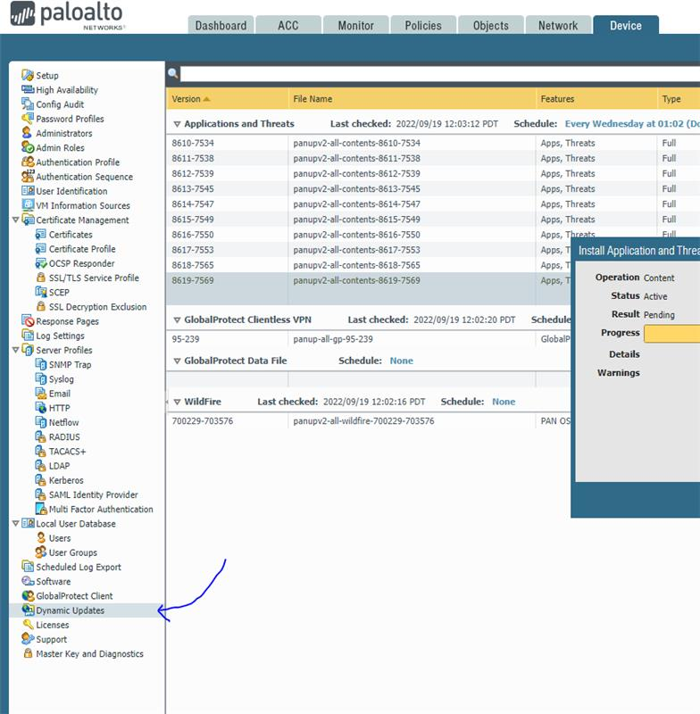

1. Download these as well

Highest number for this one





**Problems**

The main issue we had in this lab was mostly how it was very time consuming. The updates during the class period required us to wait extended periods of time every day. Also, there was one instance where we missed an update, and it took us a long time to find the update we forgot. Both these incidents caused us some setbacks during the lab, delaying the completion.

**Conclusion**

In this lab, we completed a license update on our firewall.